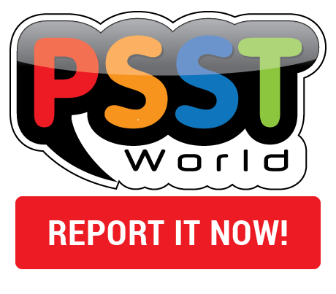
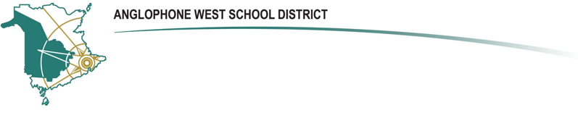
Announcements for School Community – February 5, 2018

Caregivers/Community
ASD-W is proud to announce its new partnership with PSSTWorld, launching a cutting-edge
school safety program into district schools. The PSSTWorld program is based on a proven 5-year pilot project designed by international safety expert, Theresa Campbell, in Surrey, BC. The program encourages student participation as a core factor in the improvement of school safety and culture. To become familiar with the PSSTWorld program, please visit:
http://psstworld.com/about-us.
At the site, students have a popularized venue to report safety concerns—whether seen,
heard or experienced—directly & anonymously to school district safety staff. Tips and reports regarding bullying, cyberbullying, abuse, sex/drug/weapons/gang crime, suicidal thoughts,
vandalism and even potential for school attack are sent directly to district safety officials. The result is an improved potential for early conflict prevention, intervention and efficient resolution. Bystander and victimized students are empowered to act. Student offenders are deterred. Students, staff, administration and caregivers now have a safe (anonymous, if necessary), organized and popularized mode of action for reporting dangerous school incidents and concerns.
Speak to your children about the importance of respecting themselves and others. Make sure to explain the key difference between “telling” and “tattling” and the purpose of the tool is to get themselves or their friends OUT of trouble and not IN to trouble. Encourage your kids to talk to you about problems at school and be sure that they know they can now easily report safety concerns.
Together, we can minimize all forms of bullying, abuse and violence in our schools.

